PERSBERICHT
30/07/2021

2021 first half results
Renault Group is ahead of its « Renaulution » plan

- Renault Group should achieve its target of €2 billion cash fixed cost reductions one year ahead of schedule: €1.8 billion have already been achieved of which €0.6 billion during this first half compared to 2019.
- Strong positive net price effect (+8.7 points on the Automotive excluding AVTOVAZ revenues), reflecting the implementation of the new commercial policy as part of “Renaulution”.
- Group operating margin at 2.8% compared to -6.5% in the first half of 2020.
- Positive Automotive (including AVTOVAZ) operating margin improving by more than €1.7 billion compared to the first half of 2020, despite the pandemic and the components crisis.
- Global sales up 18.7% in the first half of 2021 compared to the first half of 2020 but still down -24.2%compared to the first half of 2019.
- Group revenues up 26.8% at €23.4 billion.
- Net result positive at €368 million.
- Automotive operational free cashflow close to breakeven (-€70 million).
- Reduction of the Automotive net debt by €0.8 billion and Automotive liquidity position at €16.7 billion at June 30, 2021.
- Despite the uncertainties in demand, the continuing negative effects of the components crisis which could lead to a production loss of about 200,000 units over the year and rising raw materials prices, Renault Group is aiming to reach a full year operating margin rate of the same order as the one of the first half.
- In line with environmental challenges, the Group’s ambition is to achieve carbon neutrality in Europe by 2040 and confirms it is on track to meet its CAFE target in 2021.

Luca de Meo, CEO of Renault Group declared: « these results are the fruits of our strategic Renaulution plan, focused on profitability. They mark only the first step in our turnaround, which should accelerate with the arrival of the new vehicles in preparation. I would like to thank all our employees for their commitment in achieving these results».

Clotilde Delbos, CFO of Renault Group declared: « we have taken an important step in the restoration of our key financial indicators, notably thanks to the return close to breakeven of our free cashflow this semester. Our strong liquidity position allows us to pursue our recovery with serenity».

Boulogne-Billancourt, 7/30/2021 – Group revenues reached €23,357 million, up 26.8% compared to the first
half of 2020. At constant exchange rates and perimeter1, Group revenues would have increased by 31.8%.
Automotive excluding AVTOVAZ revenues amounted to €20,339 million, up 29.3% compared to the first half of 2020. The recovery of the automotive market is contributing +23.7 points. The implementation of the new commercial policy, focusing on profitable volumes, led to a positive net price effect of 8.7 points and a negative « volume performance » of -8.7 points.
The currency effect was negative -3.9 points mainly linked to the devaluation of the Argentinian peso, the Russian Ruble, the Turkish lira and the Brazilian real.
The product mix effect is positive by +2.9 points, thanks to the success of the launch of Arkana which marks the brand's come back in the C-segment, and to the performance of light commercial vehicles.
The “Others" effect, positive by +6.8 points, came from the increase in the contribution of parts and accessories and the recovery of the network business, which was heavily impacted by the confinement measures in the first half of 2020.
The Group recorded a positive operating margin of €654 million representing 2.8% of revenues compared to -€1,203 million in the first half of 2020.
The Automotive excluding AVTOVAZ operating margin was up +€1.6 billion to -€41 million.
Volume and sales to partners effect had a positive impact of €487 million.
Mix/price/enrichment effect was positive €599 million thanks to the impact of the new commercial policy in Europe and price increases in emerging countries to cover forex impact in the first place.
The “productivity” effect (purchasing, warranty, R&D, manufacturing and logistics, G&A) was positive €219 million notably thanks to the performance of purchasing (€143 million).
Currencies and raw materials weighed respectively for -€70 million and -€76 million.
The “Others" effect amounted to +€454 million explained notably by the impact of the recovery of the dealers’ business and the aftersales activity.
The operating margin of AVTOVAZ amounted to €118 million up +€120 million, mainly reflecting the increase in volumes and prices compared to the first half of 2020.
Sales Financing contributed €593 million to the Group operating margin compared with €469 million in the first half of 2020. This increase is mainly due to the improvement in the cost of risk. The total cost of risk reached 0.16% of the average performing assets compared to 0.99% in the first half 2020 reflecting the return to normal market conditions and the favourable update of the provisioning at the end of June 2021. Operating expenses represented 1.35% of average performing assets compared to 1.29% in the first half of 2020. This increase is explained by the sharp drop in average network performing assets in connection with the strategy of optimising vehicle stocks.
Other operating income and expenses stood at -€83 million mainly explained by provisions for restructuring costs (compared to -€804 million in the first half of 2020).
After taking into account the other operating income and expenses, Group operating income came to €571 million compared with -€2,007 million in the first half of 2020.
Net financial income and expenses amounted to -€163 million, compared with -€214 million in the first half of 2020.
______________________________
1 In order to analyze the change in consolidated revenues at constant exchange rates, Renault Group recalculates revenues for the current period by applying the average exchange rates of the previous period.

The contribution of associated companies came to €160 million, compared with -€4,892 in the first half of 2020. It is worth noting that Nissan contribution in the first half 2020 included -€4,290 million of impairments and restructuring costs (including -€1,934 million of IFRS restatements).

Current and deferred taxes represented a charge of -€200 million compared with a charge of -€273 million in the first half of 2020.

Net income reached €368 million and net income, Group share totalled €354 million (€1.30 per share compared with -€26.91 per share in the first half of 2020).

Automotive operational free cash flow was negative at -€70 million after taking into account -€302 million of restructuring expenses, a positive free cash flow for AVTOVAZ of €294 million and a negative impact of the change in working capital requirement for -€410 million. Cash flow excluding AVTOVAZ and restructuring expenses amounted to €1.8 billion (compared to €22 million in the first half of 2020). Investments in the first half of 2021 amounted to €1.5 billion compared to €2.5 billion in the first half of 2020.

At June 30, 2021, total inventories (including independent dealers) represented 427,000 vehicles compared with 547,000 at the end of June 2020.

The Automotive activity at June 30, 2021 held €16.7 billion of liquidity reserves. The Automotive net debt stood at €2.7 billion at June 30, 2021 down -€0.8 billion compared to the first half of 2020.

2021 Outlook

Despite the uncertainties in demand, the continuing negative effects of the components crisis which could lead to a production loss of about 200,000 units over the year and rising raw materials prices, Renault Group is aiming to reach a full year operating margin rate of the same order as the one of the first half.

Renault Group consolidated results

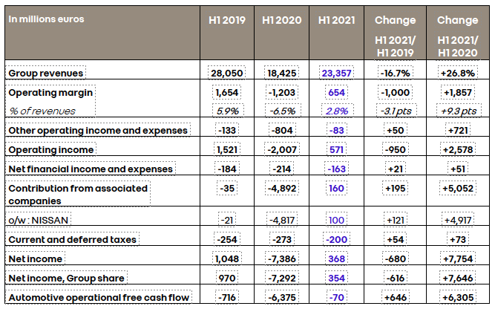

Additional information

The condensed half-year consolidated financial statements of Renault Group at June 30, 2021 were reviewed by the Board of Directors on July 29, 2021.
The Group’s statutory auditors have conducted a limited review of these financial statements and their half-year report will be issued shortly.
The financial report, with a complete analysis of the financial results in the first half of 2021, is available at www.group.renault.com in the Finance section.

About Renault Group
Renault Group is at the forefront of a mobility that is reinventing itself. Strengthened by its alliance with Nissan and Mitsubishi Motors, and its unique expertise in electrification, Renault Group comprises 5 complementary brands - Renault, Dacia, LADA, Alpine and Mobilize - offering sustainable and innovative mobility solutions to its customers. Established in more than 130 countries, the Group has sold 2.9 million vehicles in 2020. It employs more than 170,000 people who embody its Purpose every day, so that mobility brings people closer. Ready to pursue challenges both on the road and in competition, Renault Group is committed to an ambitious transformation that will generate value. This is centred on the development of new technologies and services, and a new range of even more competitive, balanced and electrified vehicles. In line with environmental challenges, the Group’s ambition is to achieve carbon neutrality in Europe by 2040. https://www.renaultgroup.com/en/

